**All components of this case study have to be executed in R.**

DATA PREPARATION:

1. Make a grouped bar chart depicting the hour-wise trip request made at city and airport respectively. You can aggregate the data for all 5 days on the same axis of 24 hours. Each bar should correspond to an hour and pick-up point (city / airport) should be displayed in two colors.

*Please paste a copy of your plot here.*

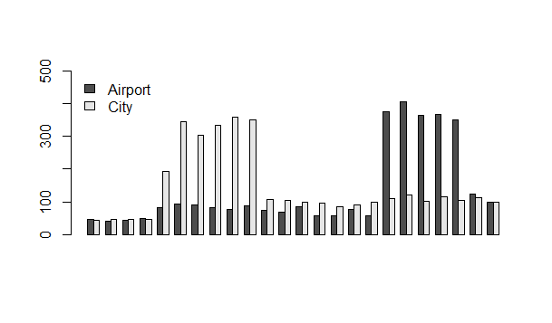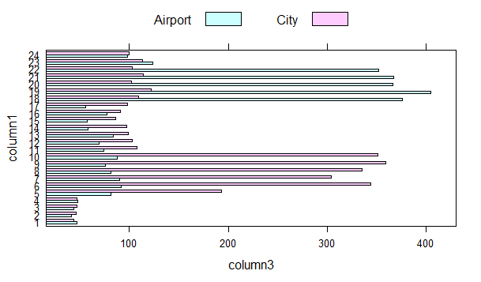

1. In the bar chart (question 1), you’ll be able to see 5 major time blocks based on the frequency of requests made at the city and airport. You have to now divide the request-time into 5 time-slots described below. Make an additional column “Time_Slot” which takes these 5 categorical values depending on the request time:
   * Pre_Morning
   * Morning_Rush
   * Day_Time
   * Evening_Rush
   * Late_Night

Note: The division of time-slots may not have one right answer.

*Plot a bar chart for number of trips made during different time-slots in R and paste the image here*

*<image>*

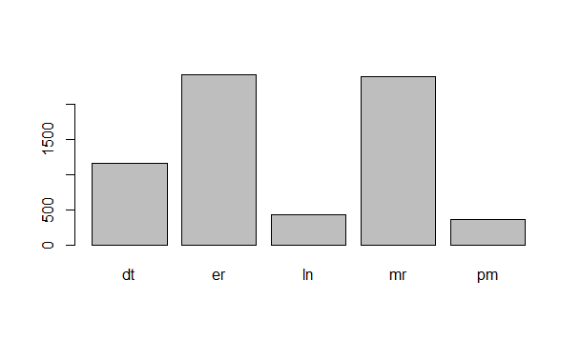 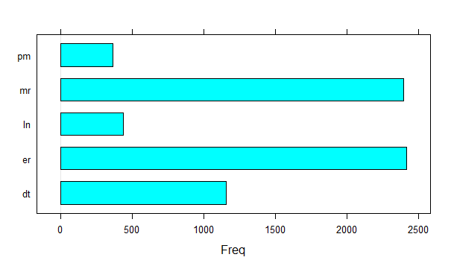

Also give the count of the number of trips made during different time slots you have decided.

* Pre_Morning:364
* Morning_Rush: 2394
* Day_Time: 1157
* Evening_Rush: 2416
* Late_Night: 435

PROBLEM IDENTIFICATION:

1. Make a stacked bar chart where each bar represents a time slot and y axis shows the frequency of requests. Different proportions of bars should represent the completed, cancelled and no cars available out of the total customer requests.

*Please paste a copy of your plot here.*

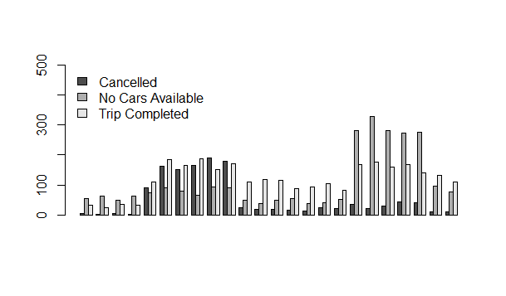

*X axis represent time here*

1. Visually identify the 2 most pressing problems for Uber, out of the 15 possible scenarios (5 slots * 3 trip status).

Problem 1: in morning Rush the number of trip cancelled is so much and no cars available is also very much.

Problem 2: in evening rush the number No car available is too large.

1. Enter your diagnosis results here:

* Problem 1: uber has to view or identify the area in which the cancellation is more and then he has to fix less driver on that area.
* Problem 2: uber has to identify the area in which the more cars has to be booked so that he can send more drivers to that side

 Problem 1:

1. For the time slot when problem 1 exists, plot a stacked bar chart to find out if the problem is more severe for pick-up requests made at the airport or the city. As a next step, you have to determine the number of times this issue exists in that time slot.

* Find the percentage breakup for the total number of issues in this time slot based on the pick-up point.

*Please paste your plot here.*

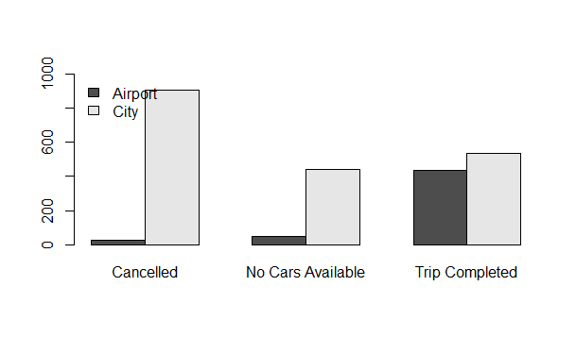

*Ans : problem is more in city*

* What is the percentage of total issues at (based on pick-up point):
* Airport : 3%
* City : 97%

1. Now let’s find out the gap between supply and demand. For this case, the demand is the number of trip requests made at the city, whereas the supply is the number of trips completed from city to the airport.

*No. of trip requests made in city:1886*

*No. of trips completed from city to airport:535*

1. What do you think is the reason for this issue for the supply demand gap? (Write the answer in less than 100 words).

Ans : I think the main problem is the cancellation of the car at that time in city due to which car is unavailable for other person.

1. What is your recommendation to Uber (Not more than 50 words)?

Ans

*I recommend that uber should implement such algorithm that can predict the chances of cancellation of a ride at a particular time and place based on the person and serve more in the area where the cancellation is less.*

Problem 2:

1. For the time slot when problem 2 exists, plot the stacked bar chart to find out if the issue is for pick-up request made at the airport or the city. Just like problem 1:

* Find the percentage breakup for issue based on the pick-up point for the time slot in which problem 2 exists.

Please paste your plot here.

*ANS 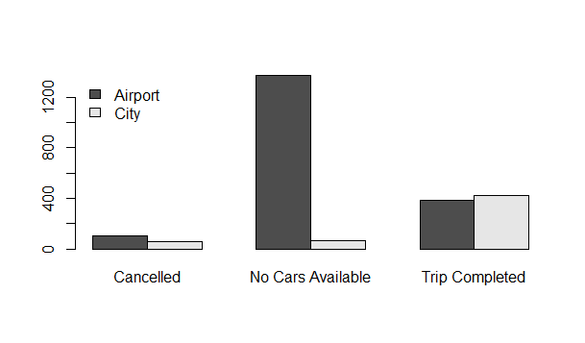*

* What is the percentage of total issues at (based on pick-up point):
* Airport : 95%
* City : 5%

1. Now let’s find out the gap between supply and demand. For this case, the demand is the number of trip requests made at the airport, whereas the supply is the number of trips completed from airport to the city.

*No. of trip requests made at the airport: 1866*

*No. of trips completed from airport to the city:387*

1. What do you think is the reason for this issue for this supply demand gap. (Not more than 100 words)?

\

ANS

I think the main problem is at this time the rush at airport is too much and before that time less number of cars get trip from city to airport due to which less number of cars are available in airport and demand is very much so this problem arises.

1. What is your recommendation to Uber (Not more than 50 words)?

Ans

I trhink that uber has to increase number of cars at this time or he has to increase the price of uber from airport to city and send more drivers to airport may be without ride also because price increased so uber suffer no loss and people also get good service .